Lab: Extending Base Entities

In this lab, you will extend base entities by modifying the data model.

Overview

Acme Insurance has a customer requirement that involves tracking information about each contact's relationship with Acme. Acme wants the new information displayed in an "Analysis" section of the user interface.

In this lab, you will modify the data model to accommodate the new information. In later labs, you will make additional changes to the data model and the user interface to complete the customer requirement.

Tasks

1. Add fields to ABContact to capture the following information. For all of them, null values are acceptable.

* WebAddress_Ext (A string of up to 40 characters – HINT: requires a parameter for the string’s length, referred to as size)
* FraudInvestigationNum_Ext (An integer)
* LastCourtesyContact_Ext (A date)
* CustomerRating_Ext (A decimal in the format XXX.Y. Values will range from 0.0 to 100.0 - HINT: add parameters for scale and precision)
* StrategicPartner_Ext (A Boolean value – HINT: ‘bit’)

The following Entity Relationship Diagram (ERD) summarizes the changes you will make in this lab. Verify that you added the correct column parameters as the hints suggested.

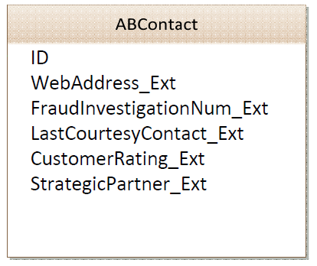

|  |  |
| --- | --- |
|  | Stop and ask your instructor to review your completed lab or compare your edited **ABContact.etx** with the solution version. |